How to mount & unmount the EBS volume in Any Linux Instance

Create the ***Base_Linux_Machine***

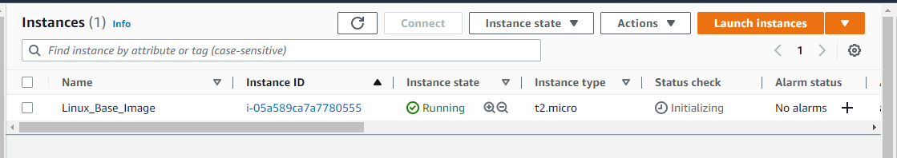

Launch the instance wai putty

Switch to root user by # sudo -s

Now need to see the list of block device # lsblk Show the file Size

Check the file types # df –hT Describe the file Types

Now we can create one Volume of 10 GB & try to map the same in ***Base_Linux_Machine*-** (ap-south-1a)

Go to AWS console & create the volume of **10 GB- Disk2**

Make sure the ***Base_Linux_Machine*** Available Zone& **Disk2 Volume** should be in same

Now go to putty with ***Base_Linux_Machine*** in putty & run the logs

We can check the machine logs in Linux with below 3 commands

# dmesg

# cat var/log/messages

# journalctl -xf

And now to check the UUID from machine as run # lsblk -f

Now we need to attach the Disk2 volume on Linux base machine

Go to volumes & attach the Disk2 to running ***Linux_Base_Machine***

After attach the volume run the below command for check the status

# lsblk

See the volume has been attach but not mount

Now we need to format the Disk2 volume with below command(ext4)

# mkfs.ext4 /dev/xvdf for extending the file system

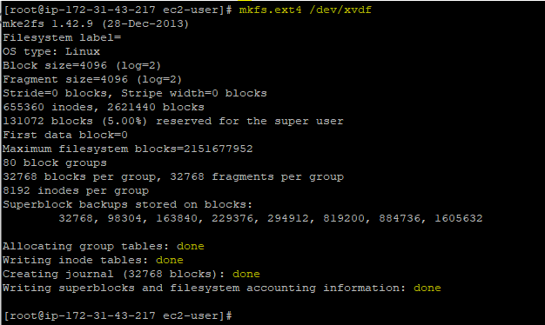

Now check the UUID - # lsblk -f

Now we can see the volume has been formatted & its shows under ***Base_Linux_Machine*** volume as well

Now we need to create the directory as # mkdir /appdir Create the Directory

Now we need to mount the disk with # mount /dev/xvdf /appdir For Mounting(Temp)

Now need to check the status with # df -h

Now we need to create on text file in appdir but 1st we need to go inside the directory with



To see the directory # pwd



Now we need to create the text file in appdir directory & add the text file # touch abc123



Check with # ls



Now we mount & its show in Linux machine as well but its temp mount as if we restart the instance it gone – let see to test so we restart the machine (***Base_Linux_Machine***) # reboot

After reboot the mount has been removed #df -h

Now we need to mount the permanent for Disk2 with below command

# nano /etc/fstab For permanently mounting

Now inside the file we can put

#/dev/xvdf /appdir ext4 defaults 0 0

And then control+X for saving the file & Yes – Y

And Enter

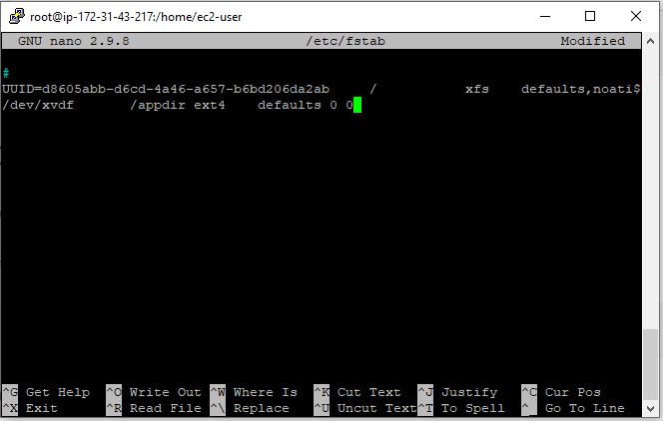

Now we can run the below command for check the mounting & status

# df -h

# mount –av To Check the mounting status

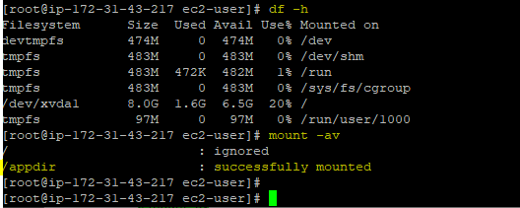

Now we can check the mounting with # df -hT

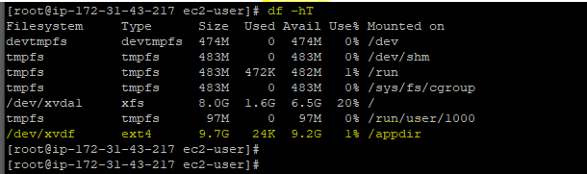

Now we reboot & check if its still there or not

# sudo -s

# df -hT

Now the **Disk2(10 GB)** volume has been **Mount permanently** ---

Now we try with unmounting with same EBS volume (Disk2-10 GB)

1st we can be unmounting the Disk2 with below command (Temp unmounting)

# umount /appdir



Check the status with # df -h

Now the Disk2 volume has been unmount & its not shows with ***Base_Linux_Machine*** but if you restart the Instance its back.

We can unmonut the disk2 permanatly with below command

# nano /etc/fstab

Just add the # in belwo & control+x And Yes (Y)----Enter

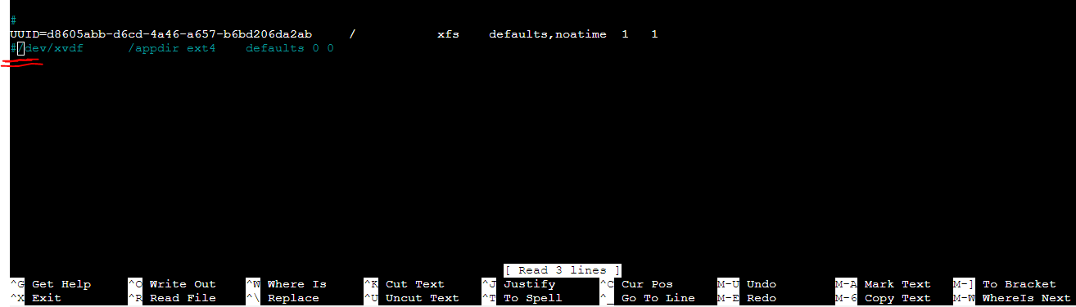

Now its permamantly removed –

Now go to Volumes (Disk2) & detach the Disk2 & reboot the instance

After remove the Disk2 my ***Base_Linux_Machine*** is start

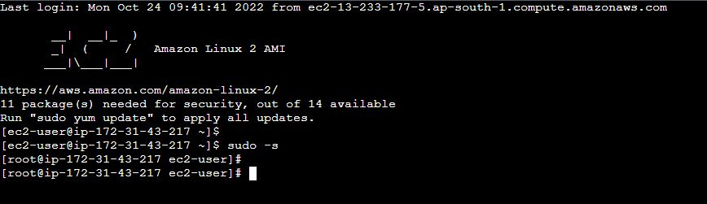

Now We Can Create the 2 different Linux instances & try to attach the Disk2 volume.

Now we can create the 2 linux instance with

1. *Linux_Server_01*
2. *Linux_Server_02*

Make sure when we create the linux instances we need to same available zone where we already create the Disk2 volume (ap-south-1a) , If we create the different AZ ,we can’t attach the Disk2 in there.

so make sure we can take same AZ.

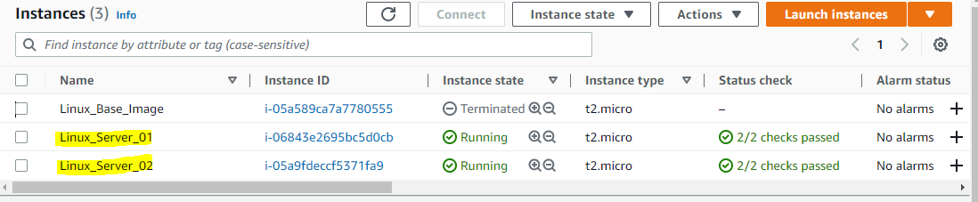

Connect the *Linux_server_01* & also go to Volumes & add Disk2 volume to *Linux_server_01*

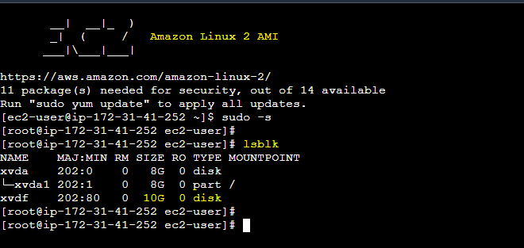

The Disk2 volume has been shows after attached from volumes Now we need to check the partitions

# lsblk -f

Now we can fresh directory as anydir in Disk2 # mkdir /anydir



Now we need to mount the Disk2 # mount /dev/xvdf /anydir

# cd /anydir

# ls

We can see the file abc123 also in there with anydir directory –

**It means data has not deleted after unmounting the volume from 1st Instance to 2nd**

Now we can detach the volume from

*Linux_Server_01* **& Attach to** *Linux_Server_02*

After that , Now we can connect with *Linux_Server_02*

We can try the below commands for check the Disk2 volume has been attached

# sudo -s

# lsblk

Now we can create the emptydir & check the file text files shown or not

# mkdir /emptydir

# mount /dev/xvdf /emptydir

# df -h

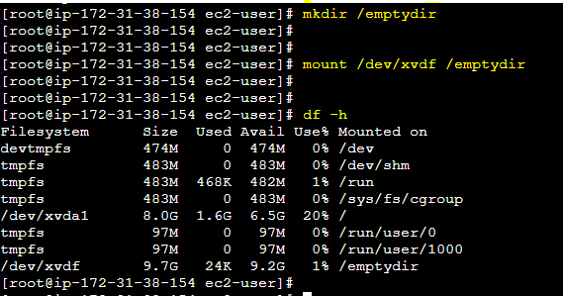

Check the file abc123 file in directory

# cd /emptydir

# ls

We can see the abc123 file in directory –means data has not lost, if we unmount the volume from 1st to 2nd Instance or 2nd to 1st Instance.

abc123 file never lost any time.

How to expand the root volume size if we need?

Go to Volumes – Select the volume – Action – Modify Volume

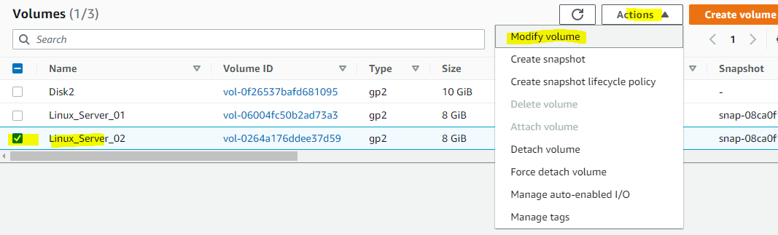

Volume Details –

Size – before its shows 8 GB I modify with 15 GB & Modify

Size has been shown as **15 GB** in volumes tab

We need to see the size of volume with # growpart /dev/xvda 1



# lsblk

# df -h

Now the Linux Instance size has been increased but Its not shows in partition so we can use below commands to shows the 15 GB size for volume

# xfs_growfs /dev/xvda1

# df -h

# Important Notes: -

* If we Modify the size for any instance & need to update one more time for doing the update as like same it not allows us to immediately as its take 6hrs for next modification.